C++ TEST SUBMISSION : PRAGUNI SANOTRA

2022A1R164

LeetCode Problem : Valid Parentheses

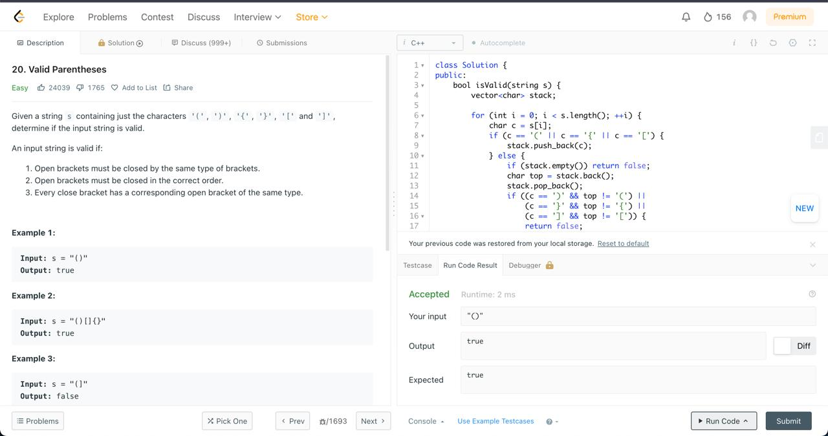

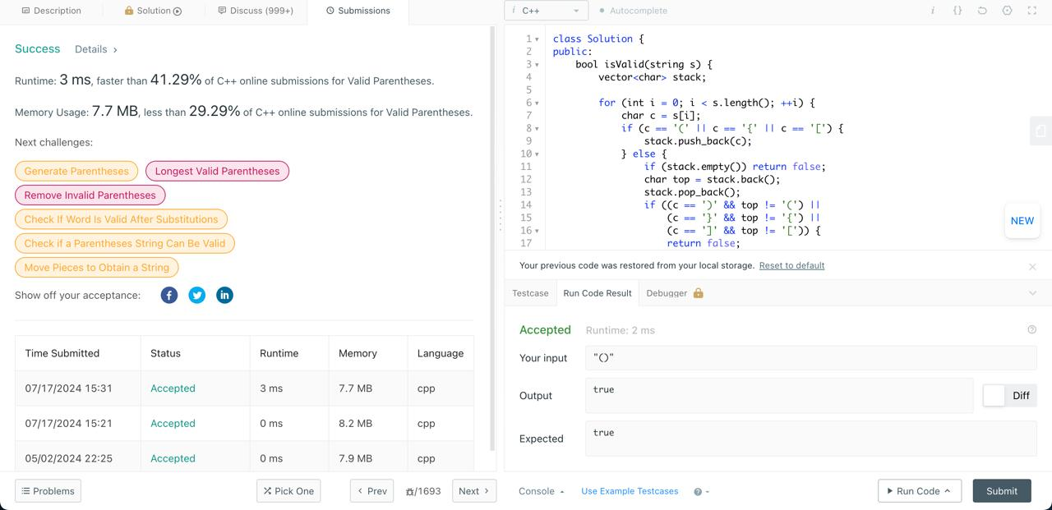

Leetcode Problem 2: Two Sum

